* **Window Server**
* **What is Windows Server Standard?**

Windows Server Standard is a powerful [operating system](https://www.theknowledgeacademy.com/blog/what-is-operating-system/) designed by Microsoft specifically for server environments. It is known to offer a range of features and functionalities essential for small to medium-sized businesses.

* **What is Windows Server Datacenter?**

Windows Server Datacenter is a high-performance, feature-rich operating system specifically designed for large-scale server deployments. It offers advanced capabilities and extensive scalability to meet the demanding requirements of enterprise-level businesses.

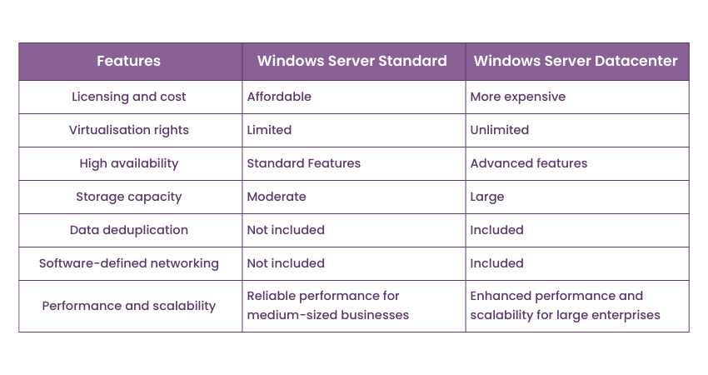

**1. Windows Server Editions:**

**a) Standard Edition**

* Designed for physical or minimally virtualized environments.
* Provides essential server capabilities like file sharing, application hosting, and Active Directory.
* Licensing includes two virtual machines (VMs) and a single Hyper-V host.

**b) Datacenter Edition**

* Ideal for highly virtualized and cloud environments.
* Offers unlimited virtualization rights.
* Includes advanced features like Storage Spaces Direct, Software-defined Networking (SDN), and Shielded Virtual Machines.

**c) Essentials Edition**

* Tailored for small businesses with up to 25 users and 50 devices.
* Includes basic server features such as file sharing and device management.
* Simplified setup and management, no need for CALs (Client Access Licenses).

**d) Hyper-V Server**

* A free standalone hypervisor for running virtual machines.
* Provides core virtualization features without the GUI of full Windows Server.

**2. Windows Server Versions:**

**a) Windows Server 2022**

* Current version with enhanced security features (Secured-core Server, HTTPS, and TLS 1.3 by default).
* Hybrid capabilities for integration with Azure.
* Enhanced support for large-scale container management.

**b) Windows Server 2019**

* Improved hybrid cloud capabilities.
* Storage Migration Service and System Insights.
* Advanced security through Shielded Virtual Machines.

**c) Windows Server 2016**

* First to introduce Nano Server and Docker container support.
* Enhanced Hyper-V and Storage Replica for disaster recovery.

**d) Windows Server 2012/2012 R2**

* Introduced Hyper-V 3.0 and Storage Spaces.
* Support for ReFS (Resilient File System).

**e) Windows Server 2008/2008 R2**

* Added Hyper-V and introduced Server Core installation.
* Extended support ended in January 2020.

**f) Windows Server 2003**

* Early adoption of 64-bit computing.
* Extended support ended in July 2015.

**3. Specialized Windows Server Types:**

**a) Windows Server Core**

* A minimal installation option for reduced resource use and increased security.
* Command-line interface only, designed for advanced users.

**b) Nano Server**

* A lightweight version of Server Core.
* Designed for running containers and cloud-native applications.
* Introduced in Server 2016 but deprecated in later versions.

**c) Azure Stack HCI**

* Combines on-premises Windows Server with Azure services.
* Focused on hybrid and hyper-converged infrastructure.

**d) Storage Server**

* Optimized for network-attached storage (NAS).
* Used for file and print sharing on dedicated hardware.
* **Window types**

1. **Modern Windows Operating Systems**

a) Windows 11

* Home: For personal use, basic features.
* Pro: Adds business tools like BitLocker, Remote Desktop, and Azure integration.
* Pro for Workstations: High-performance, supports ReFS and persistent memory.
* Enterprise: Advanced security and management for large businesses.
* Education: Tailored for schools and academic institutions.

b) Windows 10

* Home: Basic edition for everyday use.
* Pro: Adds advanced security and device management tools.
* Pro for Workstations: For high-end hardware and demanding tasks.
* Enterprise: Advanced tools for enterprise-level management.
* Education: Focused on schools and students.
* S Mode: A lightweight version, running only Microsoft Store apps.

2. **Specialized Windows Versions**

a) Windows IoT (Internet of Things)

* IoT Core: For small embedded devices (e.g., IoT appliances).
* IoT Enterprise: Full Windows experience for industrial devices.

b) Windows Mixed Reality

* Designed for VR and AR hardware.

c) Windows Embedded

* Used in ATMs, kiosks, and medical devices. Examples include Windows Embedded Standard and Windows Embedded Compact.

d) Windows Mobile

* For smartphones (discontinued, replaced by Android/iOS). Examples include Windows Phone 7, 8, and Windows 10 Mobile.

e) Windows S Mode

* A security-focused, streamlined version of Windows 10/11.

**3. Legacy Windows Versions**

a) Windows 8/8.1 (2012–2016)

* Core/Home: For standard use.
* Pro: Added business tools.
* Enterprise: For large-scale organizations.
* RT: Lightweight version for ARM devices.

b) Windows 7 (2009–2020)

* Starter: Lightweight version for netbooks.
* Home Basic: For emerging markets.
* Home Premium: For personal/home use.
* Professional: Geared toward small businesses.
* Enterprise: For enterprise-level deployment.
* Ultimate: Comprehensive, with all features.

c) Windows Vista (2006–2017)

* Editions: Starter, Home Basic, Home Premium, Business, Enterprise, Ultimate.

d) Windows XP (2001–2014)

* Editions: Home, Professional, Media Center, Tablet PC, Embedded, Starter.

e) Windows 2000 (1999–2010)

* Editions: Professional, Server, Advanced Server, Datacenter Server.

f) Windows 95, 98, ME (1995–2000)

* Early consumer operating systems with GUI enhancements.

**4. Server and Hybrid Solutions**

* Windows Server Editions: Standard, Datacenter, Essentials.
* Azure Stack: Hybrid cloud integration for businesses.